TUGAS UJIAN AKHIR SEMESTER WHITE BOX TESTING DAN BLACK BOX TESTING SISTEM PENGGAJIAN



Disusun oleh :

Nama: Fifi Dwi Ariani

Nim : 16090062

Kelas : 6C

Prodi : D4-Teknik Informatika

**POLITEKNIK HARAPAN BERSAMA KOTA TEGAL**

**2019**

1. **Latar Belakang**

Sistem Penggajian adalah sistem yang menyediakan data penggajian karyawan. Selain itu sistem ini juga dibuat untuk memenuhi tugas dari mata kuliah Framework Programming. Pada mata kuliah Rekayasa Perangkat Lunak, sistem ini dipakai untuk menerapkan White Box Testing dan Black Box Testing pada sebuah sistem sebagai syarat untuk memenuhi tugas Ujian Akhir Semester (UAS) mata kuliah tersebut.

1. **White Box Testing**
2. Flowchart
3. Admin

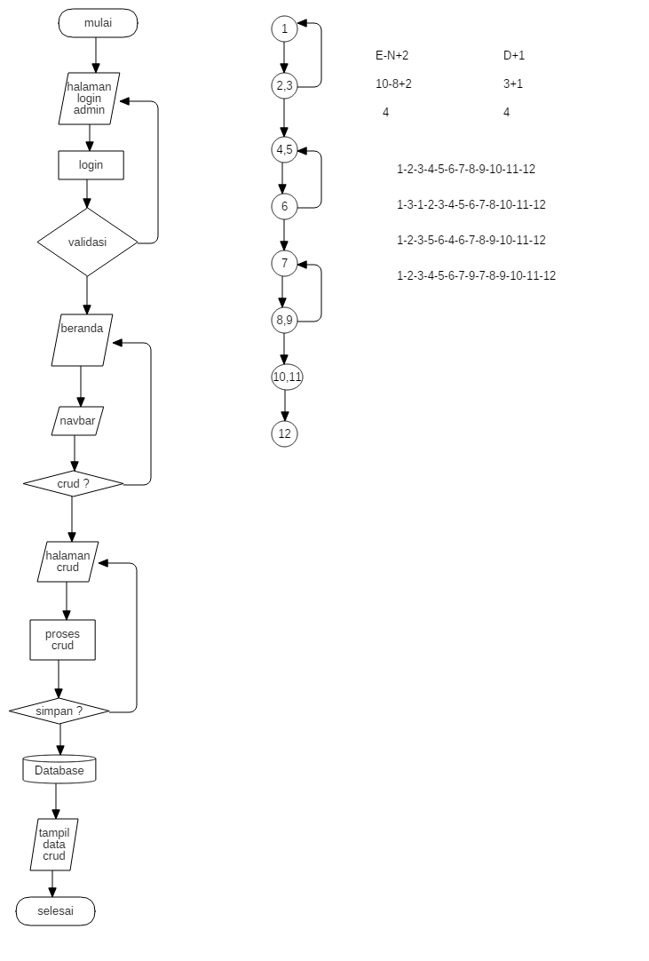

1. Pimpinan

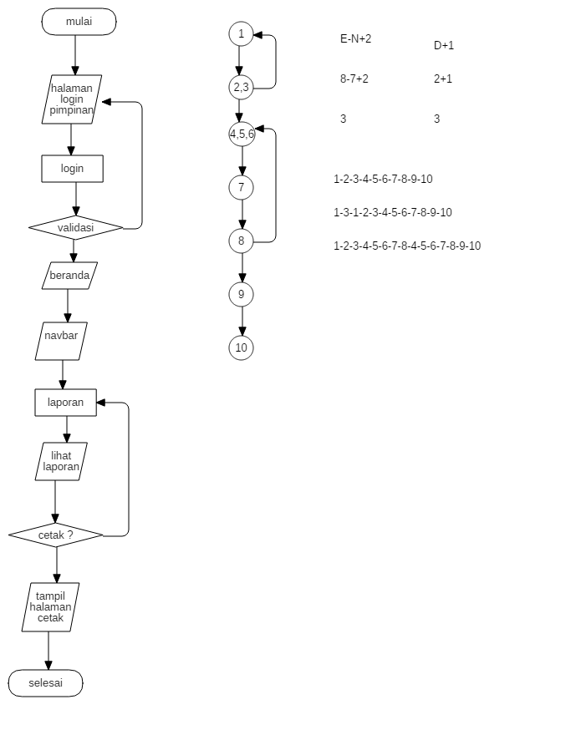

1. **Control Flow Graph**
2. Admin



1. Pimpinan



1. **Cyclomatic Complexity Value**
2. Admin



1. Pimpinan



1. **Basic Path dan Path**
2. Admin



1. Pimpinan



1. **Black Box Testing**

Kita akan menguji sistem menggunakan black box testing dengan teknik boundary value analysis (BVA) dan menggunakan tabel kebenaran.

1. **Boundary Value Analysis (BVA).**
2. Tabel Login

|  |  |  |  |  |
| --- | --- | --- | --- | --- |
| **Nama Kolom** | **Invalid** | **Valid** | **Invalid** | **Valid** |
| Username | 0 Character | 1 Character | 11 Character | 10 Character |
| Password | 0 Character | 1 Character | 21 Character | 20 Character |

1. Tabel Data Karyawan

|  |  |  |  |  |
| --- | --- | --- | --- | --- |
| **Nama Kolom** | **Invalid** | **Valid** | **Invalid** | **Valid** |
| NIP | 0 | 1 | 11 Character | 10 Character |
| Nama | 0 Character | 1 Character | 21 Character | 20 Character |
| Ttl | 0 | 1 Character | 21 Character | 20 Character |
| Jenis Kelamin | 0 Character | 1 Character | 11 Character | 10 Character |
| No Telp | 0 | 1 Character | 12 Character | 11 Character |
| Jabatan | 0 Character | 1 Character | 15 Character | 14 Character |

1. Tabel Data User Login

|  |  |  |  |  |
| --- | --- | --- | --- | --- |
| **Nama Kolom** | **Invalid** | **Valid** | **Invalid** | **Valid** |
| ID | 0 | 1 | 11 Character | 10 Character |
| Nama | 0 Character | 1 Character | 21 Character | 20 Character |
| Username | 0 | 1 Character | 21 Character | 20 Character |
| No Telp | 0 Character | 1 Character | 11 Character | 10 Character |
| Status | 0 | 1 Character | 12 Character | 11 Character |

1. Tabel Data Prestasi Karyawan

|  |  |  |  |  |
| --- | --- | --- | --- | --- |
| **Nama Kolom** | **Invalid** | **Valid** | **Invalid** | **Valid** |
| NIP | 0 | 1 | 11 Character | 10 Character |
| Nama | 0 Character | 1 Character | 21 Character | 20 Character |
| Tanggal | 0 | 1 Character | 21 Character | 20 Character |
| Prestasi | 0 Character | 1 Character | 11 Character | 10 Character |

1. **Tabel Kebenaran**
2. Form Login

|  |  |  |
| --- | --- | --- |
| **username** | **Password** | **Action** |
| Blank | Blank | No |
| Blank | True | No |
| Blank | False | No |
| False | True | No |
| False | False | No |
| False | True | No |
| True | False | No |
| True | Blank | No |
| True | True | Success |

User akan berhasil login apabila username dan password bernilai benar (true).

1. Form Tambah Data Karyawan

|  |  |  |  |  |  |
| --- | --- | --- | --- | --- | --- |
| **Nip** | **Nama** | **Ttl** | **Jenis Kelamin** | **Jabatan** | **Action** |
| Blank | Blank | Blank | Blank | Blank | No |
| Blank | False | False | False | False | No |
| Blank | True | True | True | True | No |
| True | True | True | True | True | Success |
| True | False | False | False | False | No |
| True | Blank | Blank | Blank | Blank | No |
| False | True | True | True | True | No |
| False | False | False | False | False | No |
| False | Blank | Blank | Blank | Blank | No |

Tambah Data Karyawan akan berhasil apabila kolom nip, nama, ttl, jenis kelamin, dan jabatan bernilai benar (true) selain itu akan gagal.

1. Form Tambah Data User

|  |  |  |  |  |  |
| --- | --- | --- | --- | --- | --- |
| **ID** | **Nama** | **Username** | **No Telp** | **Status** | **Action** |
| Blank | Blank | Blank | Blank | Blank | No |
| Blank | False | False | False | False | No |
| Blank | True | True | True | True | No |
| True | True | True | True | True | Success |
| True | False | False | False | False | No |
| True | Blank | Blank | Blank | Blank | No |
| False | True | True | True | True | No |
| False | False | False | False | False | No |
| False | Blank | Blank | Blank | Blank | No |

Tambah Data Karyawan akan berhasil apabila kolom id, nama, username, no telp, dan status bernilai benar (true) selain itu akan gagal.

1. Form Tambah Data Prestasi Karyawan

|  |  |  |  |  |
| --- | --- | --- | --- | --- |
| **NIP** | **Nama** | **Tanggal** | **Nama Prestasi** | **Action** |
| Blank | Blank | Blank | Blank | No |
| Blank | False | False | False | No |
| Blank | True | True | True | No |
| True | True | True | True | Success |
| True | False | False | False | No |
| True | Blank | Blank | Blank | No |
| False | True | True | True | No |
| False | False | False | False | No |
| False | Blank | Blank | Blank | No |
| Blank | Blank | Blank | True | No |
| Blank | Blank | Blank | False | No |

Tambah Data Prestasi Karyawan akan berhasil apabila kolom nip, nama, tanggal, dan nama prestasi bernilai benar (true) selain itu akan gagal.

1. **Screnshoot Sistem**
2. Form Tambah Data Karyawan

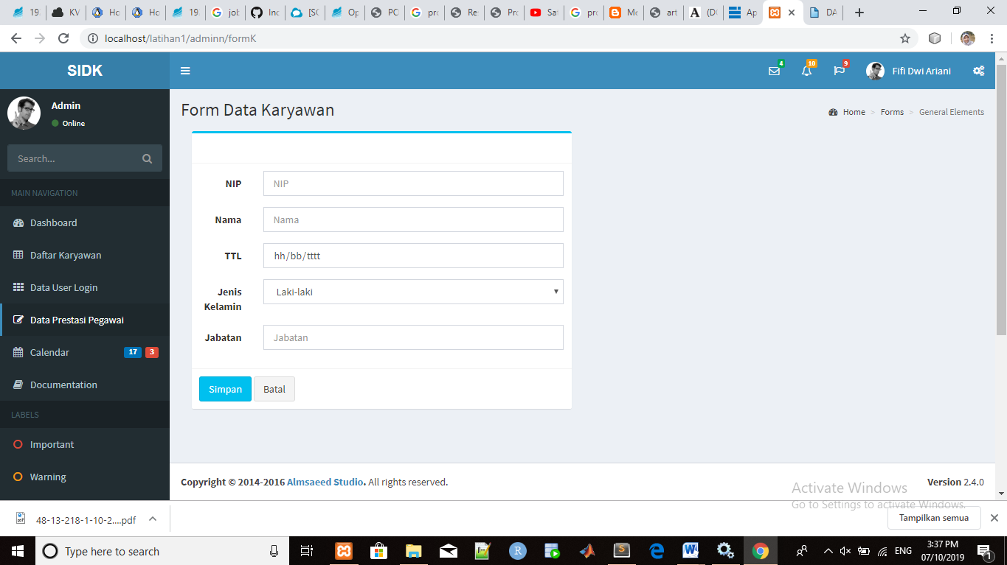

Jika salah satu kolom tidak diisi maka data karyawan tidak dapat di simpan, maka form harus diisi secara lengkap.

1. Form Tambah Data User

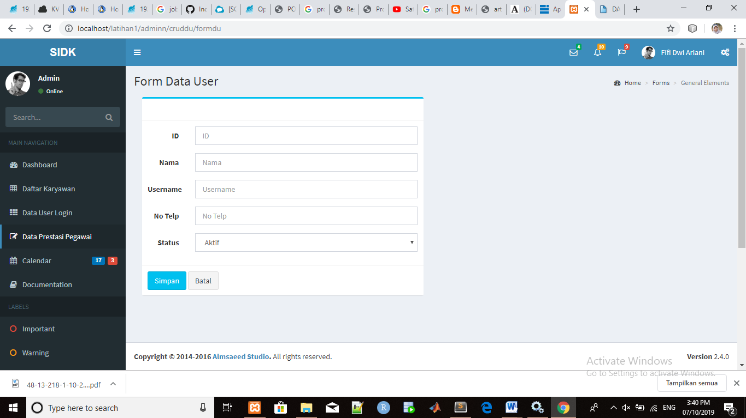

Jika salah satu kolom tidak diisi maka data user tidak dapat di simpan, maka form harus diisi secara lengkap.

1. Tambah Form Data Prestasi Pegawai

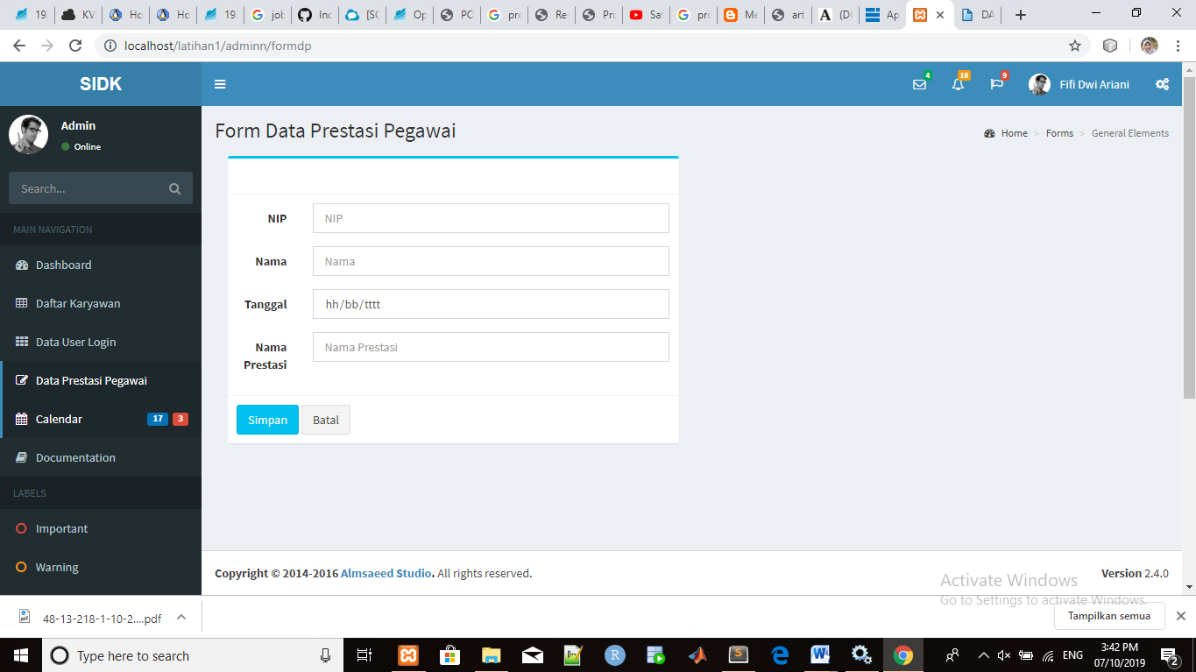

Jika salah satu kolom tidak diisi maka data prestasi pegawai tidak dapat di simpan, maka form harus diisi secara lengkap.